**Objectives:**

* To begin planning for the next project to be undertaken by the Grade 12 team.
* To apply the Planning and Analysis phases of the Software Design lifecycle to define, structure, and document the objectives and timelines for the project.

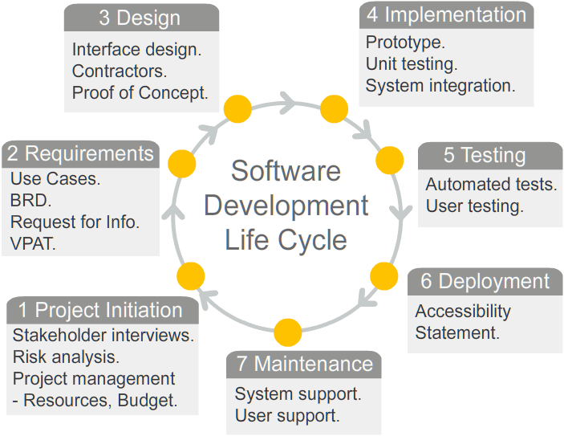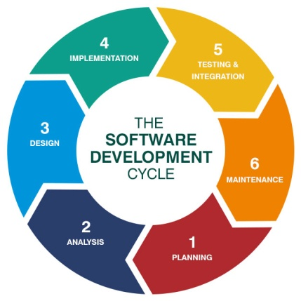

**Level 1: Problem Definition**

Problem definition is the starting point for the Planning phase of the SDLC (Software Development Life Cycle).

1. Brainstorm with your team the high level definition of your next project. Summarize your thoughts on the following topics.
   1. The look and feel of your project. (i.e. User interface and experience.)
   2. The operation and key objectives regarding how your project works.   
      (i.e. Internal code logic.)
   3. The tools and java packages (e.g. Swing) and Assets (e.g. graphics) that you will need to implement your project.
   4. What new things you will have to learn and the new skills you will have to develop to implement your project.
   5. The "would be nice" features of your project that might not be possible to achieve given your skill set and timelines.
   6. The "cannot live without" features of your project that must be achieved.
2. Create a short presentation about your problem proposal with the following objectives:
   1. The audience will be the grade 11 students.
   2. Summarize and explain the "big idea" of your project. Include graphic elements where possible.
   3. List some questions / unknowns that you have about the "user perspective" of your project. (E.g. Missing or most useful features / options.)
   4. Collect feedback from your audience regarding your project and list of questions. Feedback must be collected in an organized way and must be properly documented.
   5. Your team will present in class. Decide on roles and responsibilities to divide the work.
3. Revise your product definition based on feedback from your presentation. Record your revisions below explaining how your answers to Question #1 have changed.

**Level 2: Project Management**

Project Management is the goal of the Planning phase of the SDLC (Software Development Life Cycle).

1. Divide your project (both programming and non-programming activities) into list of specific tasks that can be assigned to members of your team.
   1. List and define each task.
   2. Organize the tasks in flow chart representing the order in which the tasks have to be done. (e.g. which tasks depend on a prior task being completed first.)
   3. Colour code your flow chart to prioritize the tasks in a list ordered by importance.
2. Assign project tasks to members of your team.
   1. Assign each project task to team member according to the member's interests and abilities.
   2. Make sure the work is distributed equitably. (not just evenly)
   3. Assign deliverable due dates to each task. The dates must be realistic and achievable.   
      Dates must also consider dependencies in the task flow chart. Update the flow chart to include these dates.

**Level 3: Analysis & Design**

This part of the module is still under development.

Project Management is the goal of the Planning phase of the SDLC (Software Development Life Cycle).

1. For each task assigned to you, document the following:
   1. Define and explain the task in detail. Break down the task into sub-tasks using bullet points.
   2. Identify what new things you will have to learn and the new skills you will have to develop to complete the task.
   3. Create a plan to complete the task by the assigned date.